Design Phase
- System Architecture
The system architecture consists of a real-time AI-driven pipeline integrated with a backend and user-facing dashboard. CCTV video input is processed through multiple stages, including motion detection, object tracking, event detection, and classification using a deep learning model. This layered architecture separates concerns between data acquisition, processing, and visualisation, improving modularity and maintainability. When a potential illegal dumping event is detected, structured event data is generated and transmitted to the backend system. The backend manages data processing, storage, and communication, while the dashboard provides real-time visualisation of alerts, trends, and geographic insights. This architecture is designed to support scalability, enabling deployment across multiple camera streams in real-world environments such as local councils and campuses.
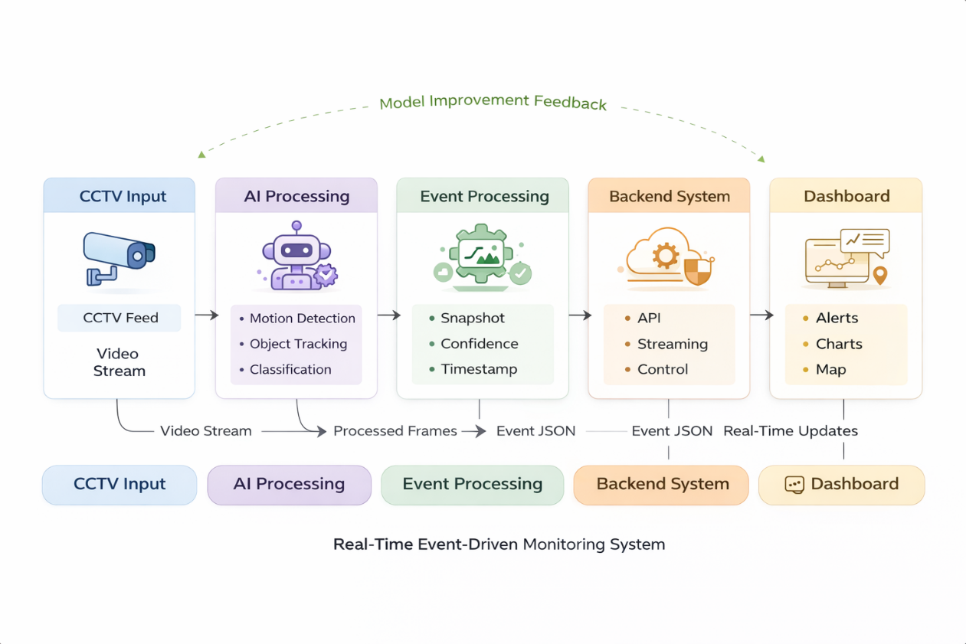

- Control Flow Design
The control flow of the system defines the step-by-step decision-making process for detecting illegal dumping events. Initially, video frames are captured from the CCTV feed. Motion detection is applied to determine whether activity is present in the scene. If no motion is detected, the system skips further processing, reducing unnecessary computation and improving efficiency. When motion is detected, objects are tracked across frames to analyse their behaviour over time. If an object becomes stationary for a defined duration, it is passed to the classification stage. The classification model determines whether the object is waste or not. If waste is detected, an event is generated and sent to the backend system, which updates the dashboard in real time. Otherwise, the object is ignored. This control flow design ensures that computationally expensive operations, such as deep learning inference, are only applied when necessary. As a result, the system achieves a balance between efficiency and accuracy, which is critical in real-time AI applications.

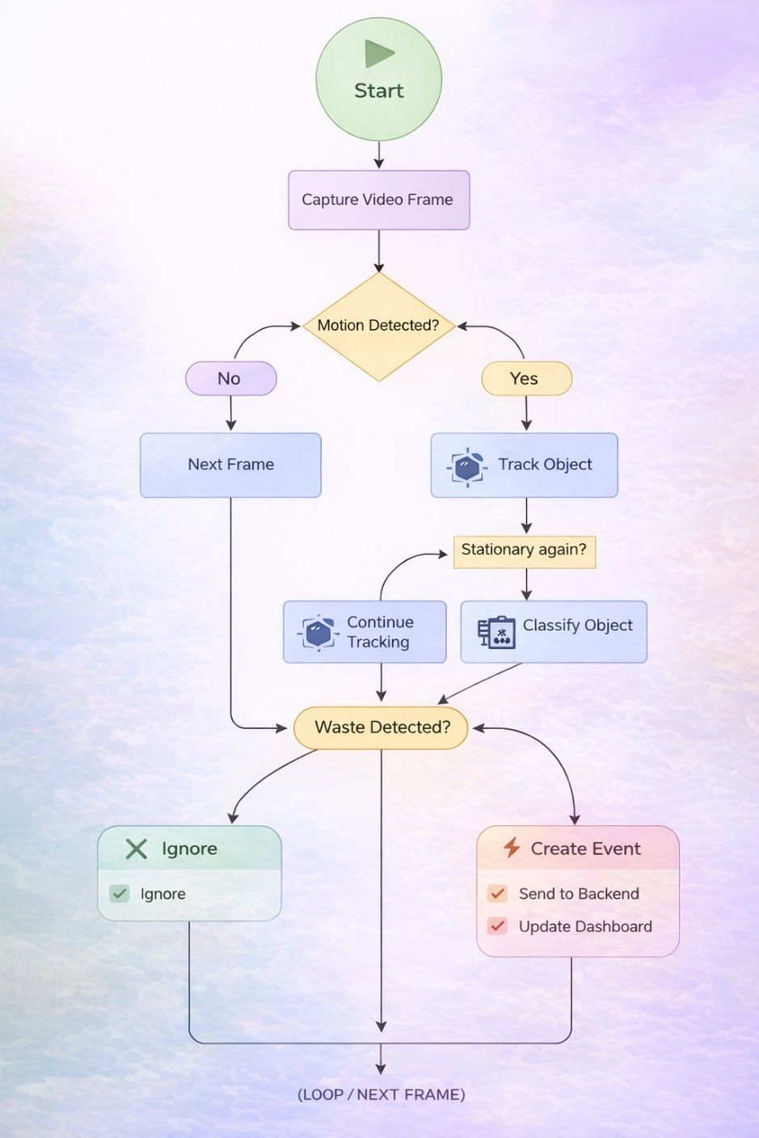

- System Intent and Impact
The system is designed to address illegal dumping in urban environments by providing an automated, real-time monitoring solution. The primary objective is to reduce reliance on manual CCTV monitoring and enable faster, more consistent detection of waste-related incidents. The system aims to improve operational efficiency, enhance urban cleanliness, and support data-driven decision-making. In addition, it considers broader impacts, including sustainability, social responsibility, and ethical implications. By enabling proactive monitoring, the system contributes to cleaner environments while supporting responsible deployment of AI in public spaces.

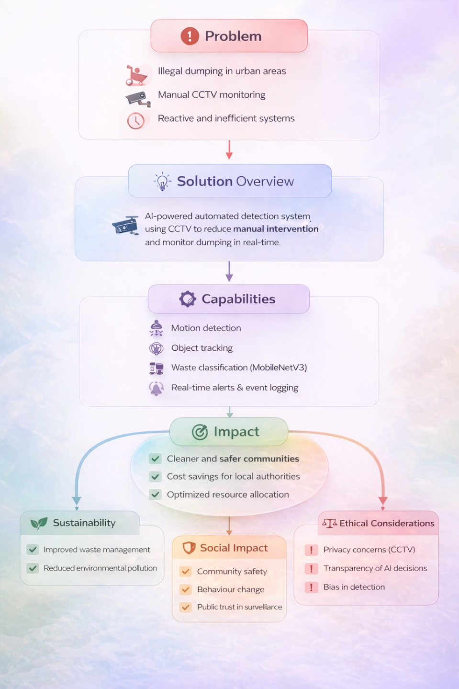
- Tools, Techniques, and Models
The system integrates a range of computer vision tools, machine learning techniques, and backend technologies to achieve real-time performance. OpenCV is used for video processing, motion detection, and object tracking due to its efficiency and suitability for real-time applications. A deep learning model based on the MobileNetV3 architecture is employed for classification. This model was selected due to its lightweight design, which enables fast inference while maintaining acceptable accuracy. Alternative models such as YOLO were considered; however, they were not selected due to higher computational requirements and reduced suitability for resource-constrained, real-time environments. The backend is implemented using Flask, providing a scalable and lightweight API framework for communication and event streaming. Streamlit is used to develop an interactive dashboard, enabling rapid development and real-time visualisation of system outputs. Additionally, a dataset conversion process is implemented to transform YOLO-formatted data into a binary classification format, ensuring compatibility with the chosen model architecture.
Category | Tool / Technology | Technique Used | Algorithm / Model | Purpose in System
Computer Vision | OpenCV | Frame capture, image processing | — | Captures and processes CCTV video streams
Motion Detection | OpenCV | Background subtraction, thresholding, morphological filtering | MOG2 Background Subtractor | Detects moving objects within video frames
Object Detection | OpenCV | Contour detection, bounding box extraction | Connected Components Analysis | Identifies object regions in the scene
Object Tracking | NumPy, OpenCV | Centroid tracking, distance-based matching | Custom Tracking Algorithm | Tracks objects across frames over time
Behaviour Analysis | Python (custom logic) | Temporal analysis, stationary object detection | Rule-based Event Detection | Identifies potential dumping events
Deep Learning | PyTorch, Torchvision | Transfer learning, feature extraction | MobileNetV3 CNN | Classifies objects as waste or non-waste
Inference | PyTorch | Softmax classification, thresholding | Neural Network Inference | Generates prediction with confidence score
Dataset Processing | OpenCV, NumPy, YAML | Cropping, dataset transformation, data preprocessing | YOLO-to-Binary Conversion | Converts YOLO dataset into classification format
Backend System | Flask | REST API development, event streaming | — | Manages system communication and data flow
Data Streaming | Python (queue, threading) | Asynchronous processing | Producer–Consumer Model | Enables real-time event handling
Data Storage | JSON | Structured logging | — | Stores detected events and metadata
Data Analysis | Pandas | Data aggregation, filtering, time-series analysis | — | Processes data for insights and trends
Visualisation | Streamlit | Interactive dashboards, charts, UI rendering | — | Displays alerts and analytics to users

- Pipeline Design
The system follows a structured multi-stage pipeline to enable efficient real-time processing of video data. The pipeline begins with video input from CCTV cameras, followed by motion detection to identify areas of activity. This initial filtering stage reduces computational overhead by ensuring that only relevant frames are processed further. Object tracking is then applied to monitor objects across frames and analyse their behaviour. Once an object is identified as stationary, it is passed to the classification stage, where a convolutional neural network determines whether it represents waste.
If waste is detected, an event is generated with associated metadata, including timestamp and confidence score. This event is then sent to the backend system for storage and further processing, and subsequently displayed on the dashboard. This staged pipeline design ensures efficient resource utilisation while maintaining real-time responsiveness.
- Design Justification
Several design decisions were made to ensure the system meets real-time performance requirements while maintaining accuracy and scalability. The MobileNetV3 model was selected due to its lightweight architecture, enabling fast inference suitable for real-time applications. While more complex models could potentially improve accuracy, they would introduce higher latency and computational costs, making them less suitable for deployment in resource-constrained environments. Motion detection is applied as an initial filtering step to reduce unnecessary processing of static frames, significantly improving system efficiency. OpenCV was chosen for its robust and optimised computer vision capabilities, while Flask provides a flexible and scalable backend solution for handling data communication. Streamlit was selected for rapid development of an interactive dashboard, allowing real-time visualisation of system outputs. Overall, these design choices reflect a balance between performance, scalability, and practical deployment requirements.

- Data Flow
Data flows sequentially through the system, beginning with the capture of video frames from the CCTV feed. These frames are processed through the AI pipeline, where motion detection, tracking, and classification are performed. When a dumping event is detected, structured event data is generated and transmitted to the backend system via API endpoints. The backend processes and stores this data, and streams it to the dashboard in real time. The dashboard then visualises the data through alerts, charts, and geographic mapping, enabling users to monitor and analyse dumping activity effectively. This continuous data flow supports real-time decision-making and ensures that relevant information is delivered to users with minimal delay.

- Constraints and Trade-Offs
The system design involves several trade-offs between performance, accuracy, and resource constraints. A key trade-off is between model complexity and real-time performance. While more complex models may offer higher accuracy, they require greater computational resources and may not meet real-time requirements. Therefore, a lightweight model (MobileNetV3) was selected. Another limitation is the availability and quality of training data. A limited dataset may affect the model’s ability to generalise across different environments and conditions. Environmental factors such as lighting variations, occlusion, and camera positioning can also impact detection performance. These constraints highlight the challenge of balancing detection accuracy with system responsiveness, which is a critical consideration in real-time AI systems.

- Scalability and Modularity
The system is designed with a modular architecture, where each component operates independently. This includes the AI processing pipeline, backend system, and dashboard interface. Such modularity enables easier maintenance, testing, and future enhancements. The architecture supports horizontal scaling through the addition of multiple camera streams and distributed backend services. Furthermore, the system can be extended into a cloud-based Software-as-a-Service (SaaS) platform, allowing deployment across multiple locations such as local councils, campuses, and private facilities.

- Ethical Considerations in Design
Ethical considerations were integrated into the system design to ensure responsible use of AI technology. The system does not use facial recognition, reducing risks associated with personal identification and privacy violations. Data minimisation principles are applied, ensuring that only relevant event data is stored.
Transparency is supported through clear visualisation of system outputs on the dashboard, allowing users to understand and interpret system decisions. Considerations were also given to potential bias in the model and the need for fair and reliable detection across different environments. These measures ensure alignment with responsible AI principles and contribute to building trust in AI-based monitoring systems.

